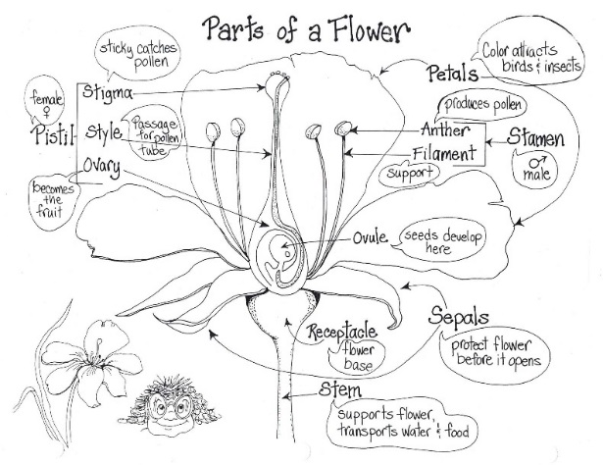
Flowers

You will need:
Parts of a Flower diagram
Crayons, colored pencils, or markers
Colored and Regular Pencils
2 Flowers
A toothpick
A magnifying glass

Directions
- Start with the petals. Remove one petal and look at it with the magnifying glass. Color the petals on the Parts of a Flower sheet the color of your flower.
-Petals are the colorful structures that help the flower attract pollinators.

- Hold the flower with one hand at the base of the petals. Remove a few petals until you can see the inner parts of the flower. Find the pistil. Color the pistil on the diagram. Look at the pistil with the magnifying glass.
-The pistil is the female part of the flower.
-The pistil includes the ovary, style, and stigma.

- Locate the stigma. Touch the stigma. See how it is sticky. Color the stigma on the diagram. Look at the stigma with the magnifying glass.
- Pollen, brought to the flower either from an insect or the wind, will attach to
the sticky stigma and this begins the process of pollination.

- Look below the stigma to see the tube-like style. Color the style on the diagram. Look at the style with the magnifying glass.
-The pollen travels down the style until it reaches the ovary where ovules are
fertilized and will develop into seeds.

- Locate the ovary at the bottom of the style. Open the large bulb like ovary and look at the developing seeds with the magnifying glass. Color the ovary on the diagram. Look at the ovary with the magnifying glass.

- Next look at the stamen. The stamen is the male part of the flower. It consists of the anther and filament. The anther carries the pollen that fertilizes the female part of the flower and is held up by the thread-like filament. Color the stamen on the diagram. Look at the stamen with the magnifying glass.

- Look at the sepals. Sepals typically function as protection for the flower in bud, and often as support for the petals when in bloom. Color the sepals on the diagram.

